1. **Introduction**

The human body relies on a constant supply of blood for vital functions like oxygen delivery, waste removal, and immune response. Unfortunately, blood is a perishable commodity with a limited shelf life. Blood banks play a crucial role in healthcare systems by collecting, processing, storing, and distributing blood components to patients in need. However, managing blood banks efficiently presents a complex logistical challenge. This project proposes the development of a comprehensive Blood Bank Management System (BBMS) to streamline operations, optimize resource allocation, and ultimately, ensure timely access to safe blood transfusions for patients.

In the realm of healthcare, blood plays a crucial role in saving lives. Every day, countless individuals require blood transfusions due to surgeries, accidents, or medical conditions such as anaemia or cancer. Ensuring a steady and safe supply of blood is essential for the functioning of any healthcare system. Blood banks serve as the cornerstone in this endeavour, acting as repositories for donated blood and facilitating its distribution to those in need.

To address these challenges, the implementation of an effective Blood Bank Management System (BBMS) is imperative. A BBMS is a software solution designed to streamline and automate the operations of blood banks, from donor registration to inventory management and beyond. By leveraging technology, a BBMS can enhance the efficiency, accuracy, and transparency of blood bank processes, ultimately improving patient outcomes and healthcare delivery.

**1.1 Problem definition**

Despite advance in technology nowadays most blood bank system is running in manual system. As such there is a present problem in the available of needed types for instance when a person needs a certain blood, and this type is not available in the hospital family member send message through social media to those who can donate to them life of this the addition it seems that there is lack of proper documentation about blood doner and its medical history.

This may lead to blood bag contamination and may affected the blood transfusion safety generally this study aims to determine how to use of online bank management system enhance blood transfusion safety.

**1.2 Study of Existing system.**

Existing system is computerized the given system is developed to manage and insert the record of doner for collection blood sample application are given for registration and form filling process. The given system is handling by manually.

Provide an overview of the landscape of existing BBMS platforms, including commercial off-the-shelf (COTS) software and custom-built solutions.

Discuss the prevalence of BBMS adoption in different healthcare settings, from small clinics to large hospital networks.

Highlight the diversity of BBMS vendors and the range of features offered by different platforms.

**1.3 Drawback of Existing system**

1) time taking process

2)possibilities of error in record keeping

3)the efficient blood inventory

4) less security.

**1.4 Scope and proposed system.**

The proposed system of the blood bank management system is the web-based system is the web-based system intends to simplify and atomate the process of searching blood in case of emergency and maintain the record of blood doner, receiver blood, blood donation programs and blood stocks in the bank. This online system replaces all paper works providing the benefit of its excellent administration and control.

1. **Analysis**

**2.1 Feasibility study**

The given website required frontend (HTML, CSS, JS) and software and database to efficient manage blood inventory, doner information and blood transfusion record.

**2.2 Economical feasibility**

The proposed system requires initial investment in the software development hardware etc. Facility has the necessary and reliability power source. If the system needs to integrate with existing healthcare system, there management but additional integrity cost. In case of BBMS may doner, leading to increased revenue through blood donation.

**2.3 Operation Feasibility**

User friendly interface the website must be user friendly easy to operate for its uses implement mechanism for uses to provide feedback and report issues with the system regularly address concerns to improve operation efficiency.

**2.4 Technical Requirements**

* Hardware Specification
* **Server Configuration**

1)Processor 2.49GHz Intel(R)

2)RAM 16GB DDR4

3)HDD 1TB

* **Client Configuration**

1)Processor 11th Gen Intel(R) Core i5

2)512GB SSD

* Software Specifications

1)Server- Linux-CentOS 8.0 version 64bits

2)Client- CentOS 8.0 Version 64bits, Windows 11

**3.Design**

**3.1 Database Table:**

1) Registration

|  |  |  |  |
| --- | --- | --- | --- |
| Sr.no | Field name | Field type | Description |
| 1 | **U id** | **Serial** | **User id (primary key)** |
| 2 | **Name** | **Varchar** | **User’s name** |
| 3 | **Email** | **Varchar** | **User’s email** |
| 4 | **Contact** | **Varchar (10)** | **User’s contact no.** |
| 5 | **Username** | **Varchar** | **Username of user** |
| 6 | **Password** | **Varchar** | **Password for users account on BBMS** |

2)Contact:

|  |  |  |  |
| --- | --- | --- | --- |
| Sr.no | Field name | Field type | Description |
| 1 | **Name** | **Varchar** | **Name of the user** |
| 2 | **Email** | **Varchar** | **Email of the user** |
| 3 | **Phone** | **Varchar** | **Contact number of users** |
| 4 | **Message** | **Varchar** | **Message for any suggestions** |

3) Available blood:

|  |  |  |  |
| --- | --- | --- | --- |
| Sr.no | Field name | Field type | Description |
| 1 | **Blood group** | **Varchar** | **Blood group of donor and receiver** |
| 2 | **Blood count** | **Varchar** | **Blood count of blood** |
| 3 | **Status** | **Varchar** | **Status of Blood count** |

4) Blood Count:

|  |  |  |  |
| --- | --- | --- | --- |
| Sr.no | Field name | Field type | Description |
| 1 | **Ap** | **int** | **A positive blood group** |
| 2 | **An** | **int** | **A negative blood group** |
| 3 | **Bp** | **int** | **B positive blood group** |
| 4 | **Bn** | **int** | **B negative blood group** |
| 5 | **Op** | **int** | **O positive blood group** |
| 6 | **On** | **int** | **O negative blood group** |
| 7 | **AB p** | **int** | **AB positive blood group** |
| 8 | **ABN** | **int** | **AB negative blood group** |

5) Doner:

|  |  |  |  |
| --- | --- | --- | --- |
| Sr.no | Field name | Field type | Description |
| 1 | **D id** | **Serial** | **Donor id (primary key)** |
| 2 | **Name** | **Varchar** | **Donor’s name** |
| 3 | **Age** | **Varchar** | **Donor’s age** |
| 4 | **Gender** | **Varchar (10)** | **Donor’s gender** |
| 5 | **weight** | **Varchar** | **Donor’s weight** |
| 6 | **Height** | **Varchar** | **Donor’s height** |
| 7 | **Occupation** | **Varchar** | **Donor’s occupation** |
| 8 | **Blood group** | **Varchar** | **Donor’s blood group** |
| 9 | **Phone** | **Varchar** | **Contact details of the donor** |
| 10 | **Email** | **Varchar** | **Donor’s Email ID** |
| 11 | **Address** | **Varchar** | **Address of donor** |

6) Receiver:

|  |  |  |  |
| --- | --- | --- | --- |
| Sr.no | Field name | Field type | Description |
| 1 | **R id** | **Serial** | **Receiver id (primary key)** |
| 2 | **Name** | **Varchar** | **Receiver’s name** |
| 3 | **Age** | **Varchar** | **Receiver’s age** |
| 4 | **Gender** | **Varchar (10)** | **Receiver’s gender** |
| 5 | **weight** | **Varchar** | **Receiver’s weight** |
| 6 | **Height** | **Varchar** | **Receiver’s height** |
| 7 | **Occupation** | **Varchar** | **Receiver’s occupation** |
| 8 | **Blood group** | **Varchar** | **Receiver’s blood group** |
| 9 | **Phone** | **Varchar** | **Contact details of the Receiver** |
| 10 | **Email** | **Varchar** | **Receiver’s Email ID** |
| 11 | **Address** | **Varchar** | **Address of receiver** |
| 12 | **Urgency category** | **Varchar** | **How urgently blood is required** |
| 13 | **Cost** | **Varchar** | **Cost of blood bag** |

**3.2 Input Output screen**

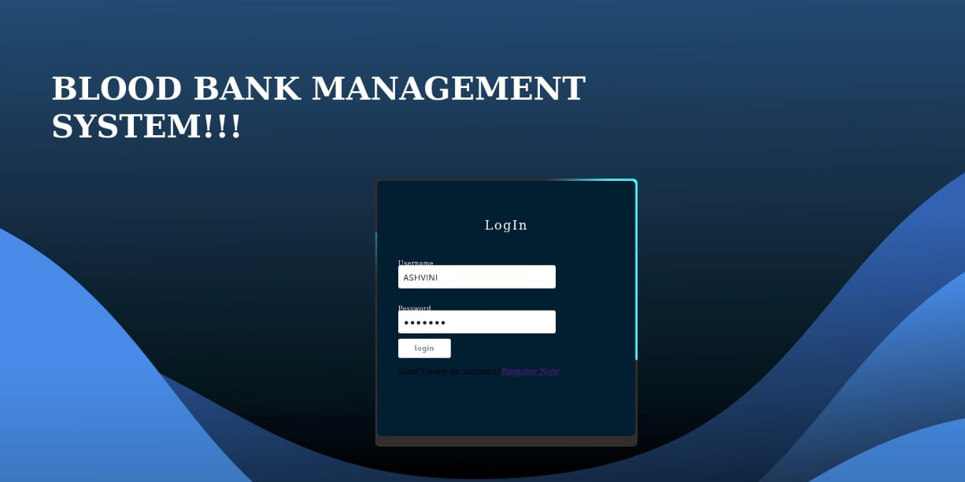

**(user and admin login page)**

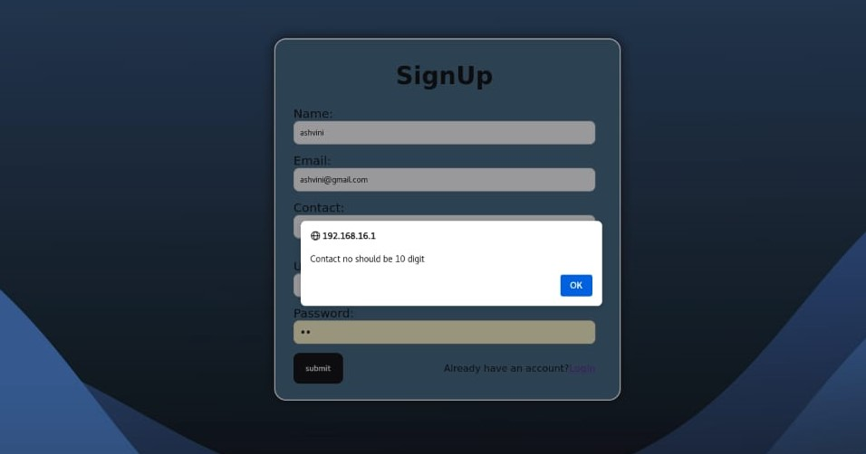**(users sign up page with validation)**

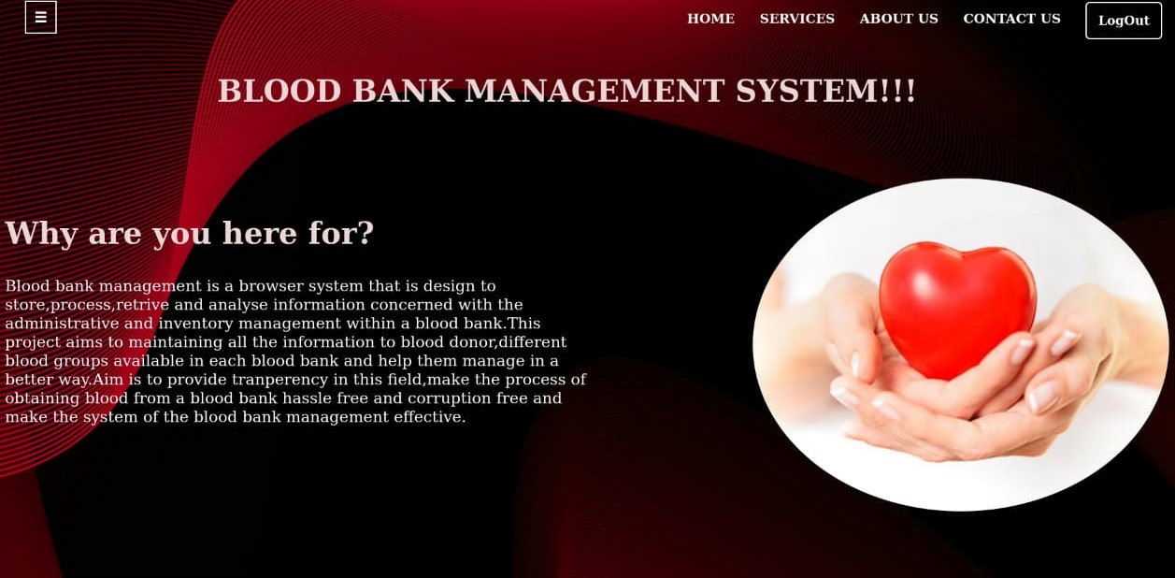

**(Home page)**

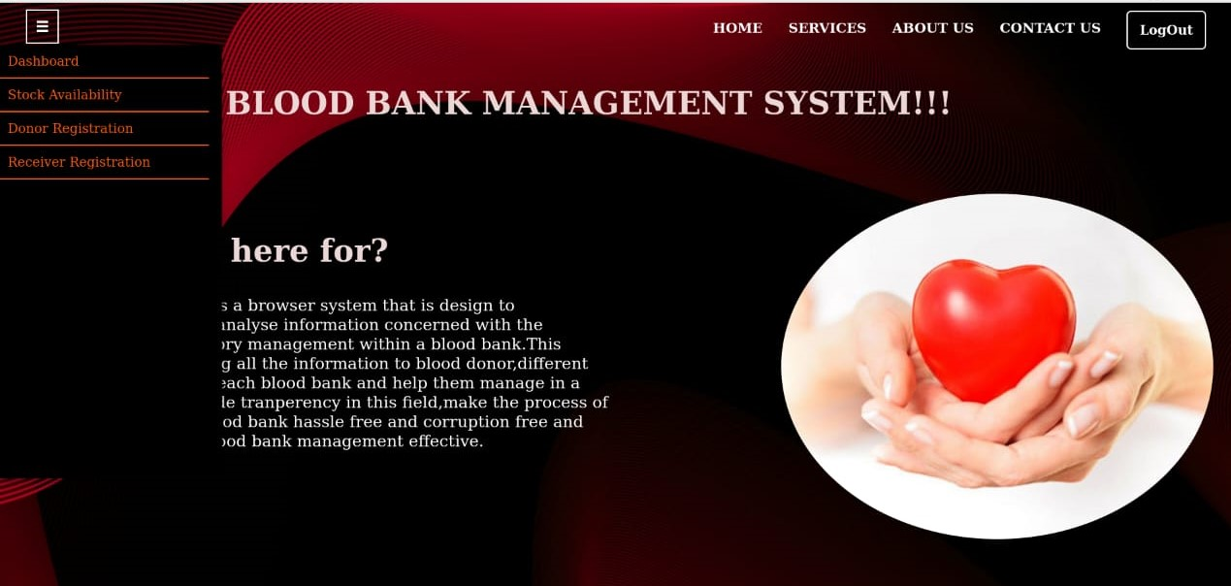

**(Home page dashboard)**

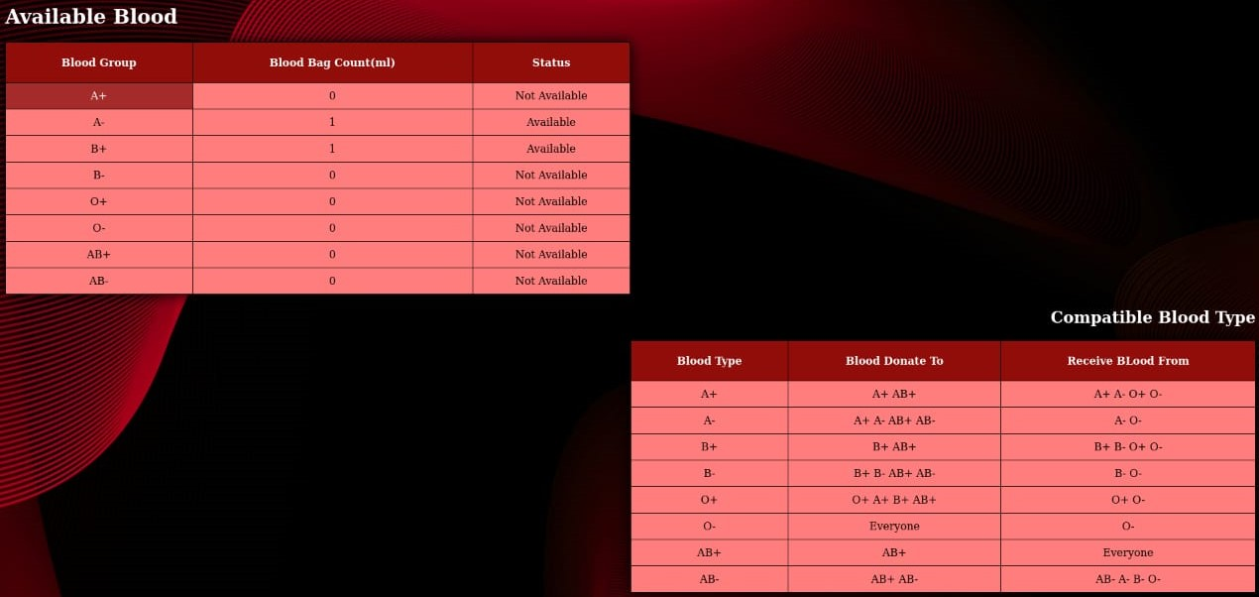

**(Available blood count and compatible blood page)**

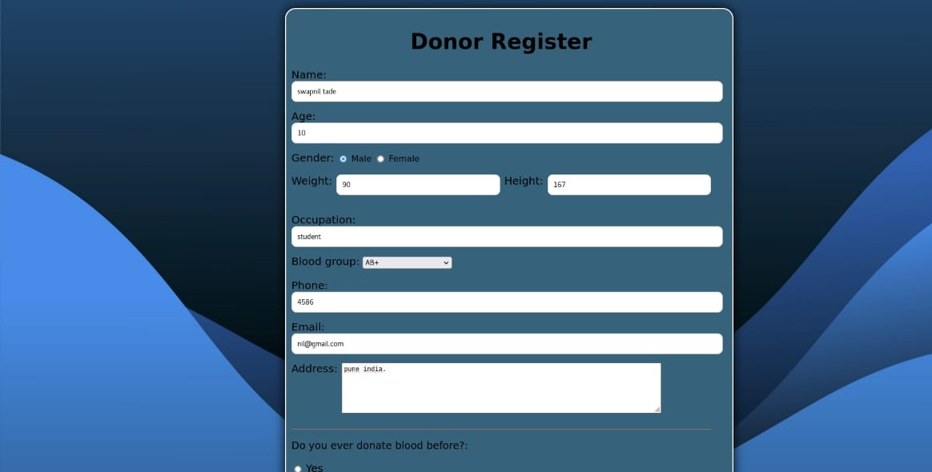

**(Doner Registration with validataion page)**

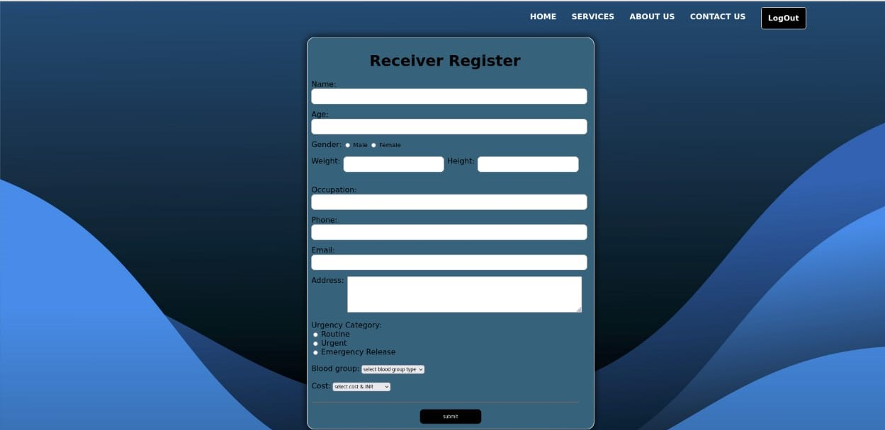

**(Receiver Registration page)**

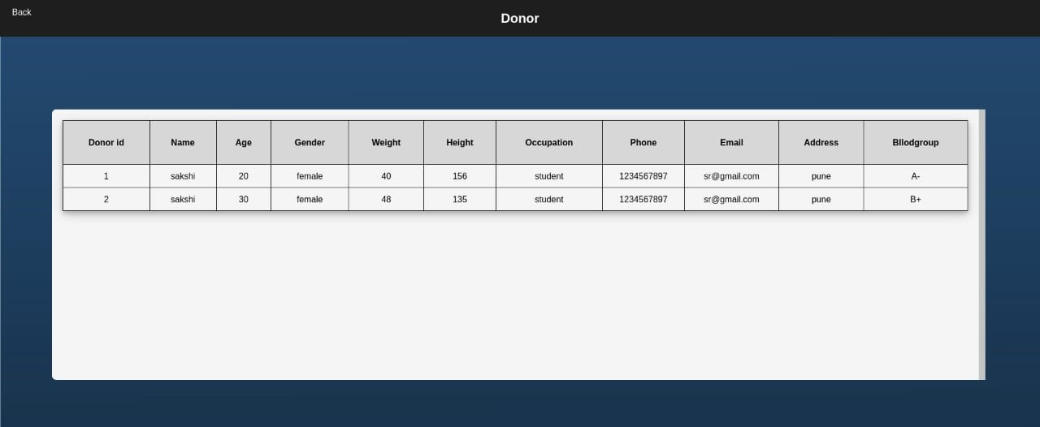

**(Doner list page)**

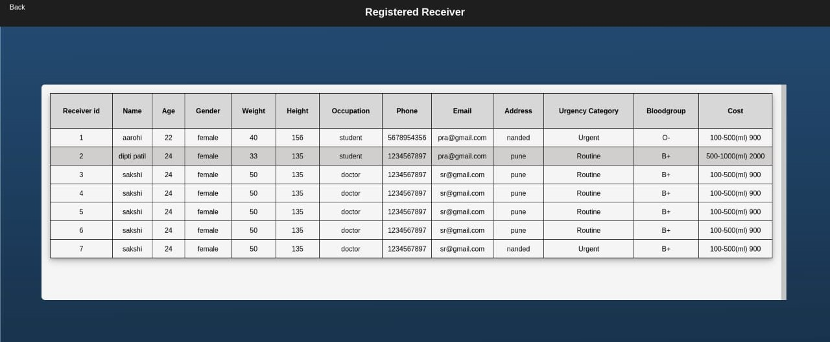

**(Receiver list page)**



**(Doner and Receiver registration successful page)**

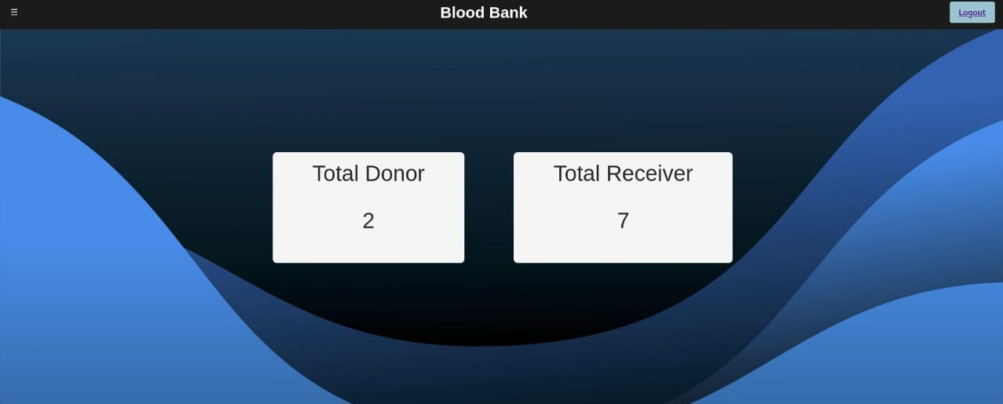

**(Dashboard doner and receiver count box page)**

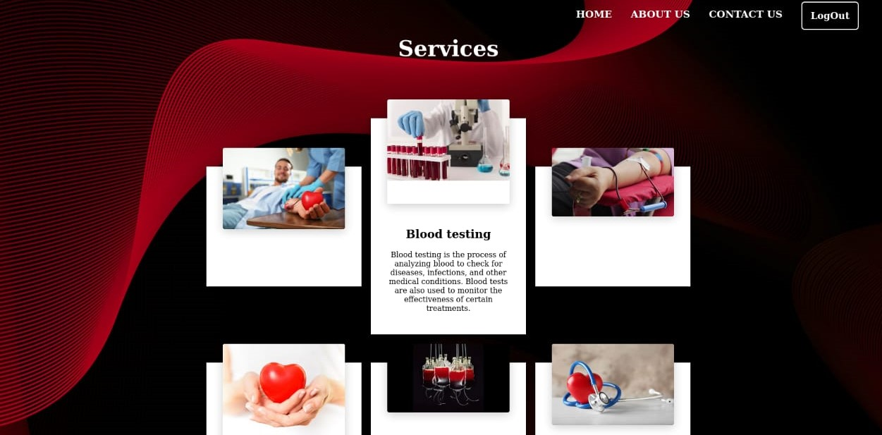

**(Services page)**

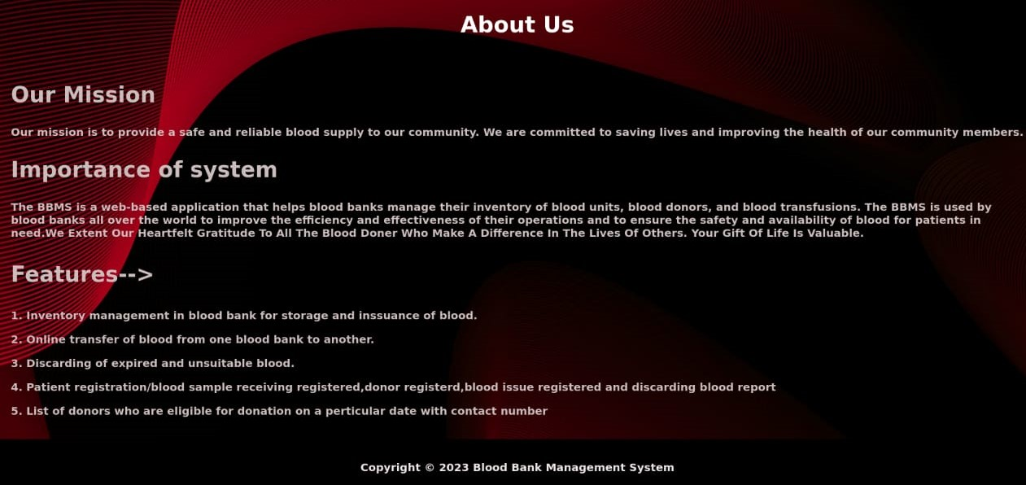

**(About us page)**

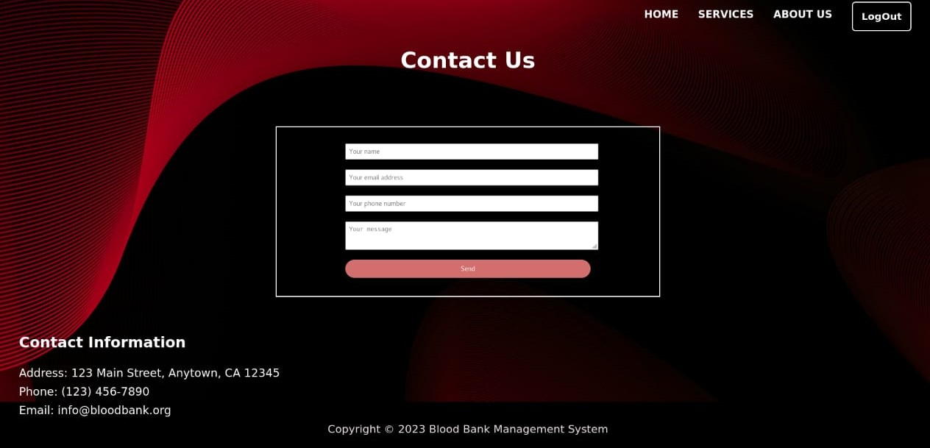

**(Contact us page)**

**4. UML**

**4.1) State diagram:**

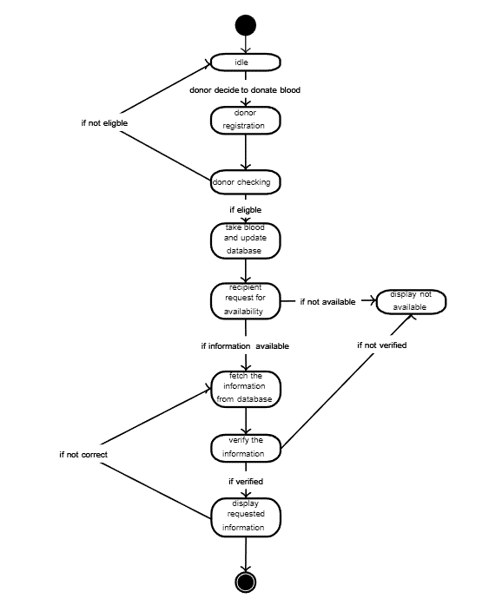

**4.2) Use Case diagram:**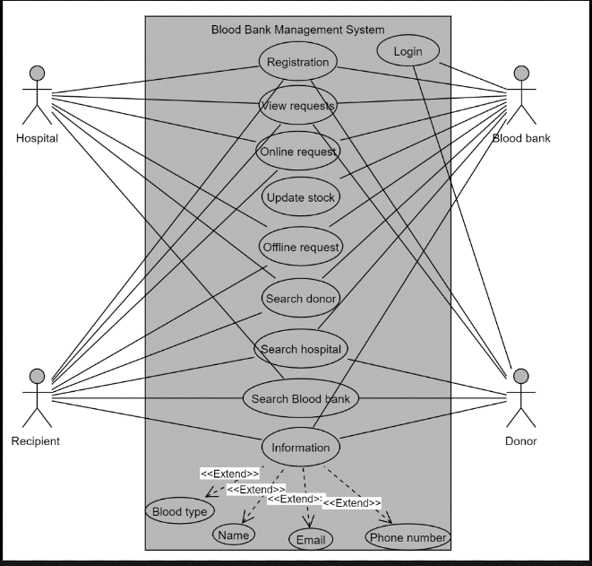

**4.3) Sequence diagram:**

**4.3) Entity relationship diagram:**

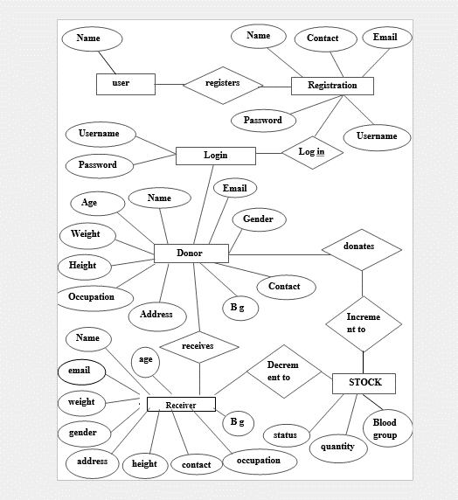

**4.5) Deployment Diagram:**

**4.6) Class Diagram:**

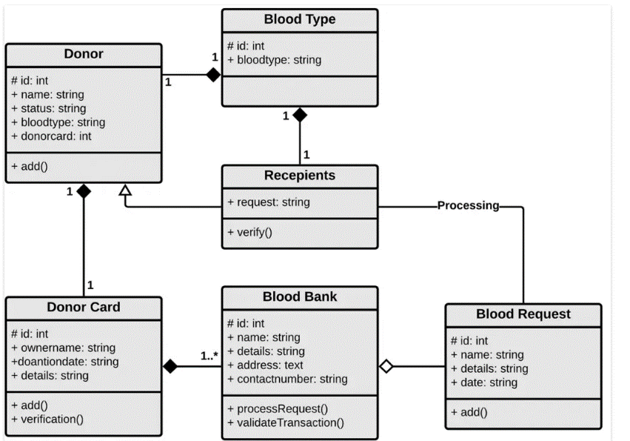

**5. Coding**

|  |  |
| --- | --- |
| Operating System | Microsoft windows7 and above  Linux |
| Graphics | Mesa Intel Graphics (RKL GT1) |
| Front**-**End | PHP Version 7.2.24 |
| Back-end | PostgreSQL version 10.17 |

**5.1 Hardware specification:**

**5.2 Platform:**

Linux operation system and windows 11

**Linux:** Open-source nature of Linux makes it a popular choice for developers. Many development tools like web servers (Apache, Nginx), PHP interpreters, and database management systems (MySQL, PostgreSQL) are readily available and often pre-installed on various Linux distributions. The command-line interface (CLI) in Linux offers a powerful and efficient environment for developers familiar with its functionalities.

**Windows 11:** While Windows 11 offers developer tools like XAMPP or WAMP for local development setups, it might require additional configuration compared to Linux. The development experience might be less streamlined compared to a native Linux environment, especially for those accustomed to the CLI.

**5.3 Programming Language Used**

1) PHP, CSS, HTML, JAVASCRIPT Language used.

**Back-end Development:**

**JavaScript:**  JavaScript will add interactivity and dynamic functionality to the BBMS. It can be used for tasks like form validation, user input handling, and creating interactive elements like calendars or data visualizations. Frameworks like Bootstrap can be leveraged on top of these core technologies to streamline development and create responsive web pages that adapt to different screen sizes.

**PHP (Hypertext Preprocessor):** PHP will serve as the server-side scripting language for the BBMS. It will handle tasks like processing user requests, interacting with the database, and generating dynamic web page content. PHP excels at handling form submissions, database communication, and server-side logic.

**Database Management System:** The BBMS will utilize a database management system (DBMS) to store and manage critical data like donor information, blood inventory, and transfusion records. Popular choices for this project could include MySQL, PostgreSQL, or MariaDB. These relational databases offer efficient storage, retrieval, and manipulation of structured data.

**5.4 Coding Style Required**

**2) CSS, HTML**

**Front-end Development:**

**HTML (Hypertext Markup Language):** HTML will provide the foundation for creating the structure and content of the web pages within the BBMS. It will define user interface elements like forms, buttons, and tables for data display.

**CSS (Cascading Style Sheets):** CSS will be used to style the HTML elements, controlling the visual appearance of the BBMS user interface. This includes elements like layout, fonts, colours, and overall user experience.

**6. Testing**

**6.1 Testcases and Test Results**

|  |  |  |  |
| --- | --- | --- | --- |
|  |  |  |  |

|  |  |  |  |
| --- | --- | --- | --- |
| Test Cases | Test Step | Excepted Output | Status |
| Registration | It will check if all the required fields are correct filled & all constraints are followed: 1) valid phone number. 2) valid entry. 3) enter correct password. | If all the filed are correctly fill will submit the data | Successful |
| Log in Page | The username and password will be check and should be match the data | if data is match it will allow login | Successful |
| Forget Password | In case user forget password, security question and username should match | Password should be display with the username. | Successful |
| Doner Registration | Correctly filled all the constrain: 1) valid age. 2)valid phone. 3)valid pin code 4) valid weight. | The form will be displaying user has filled appropriate details | Successful |
| Receiver Registration | Correctly filled all the constrain: 1) valid age. 2)valid phone. 3)valid pin code 4) valid weight. | The form will be displaying user has filled appropriate details | Successful |
| Logout | Go to logout click the button. | Log out the website and display login page | Successful |

**7. Limitation and Future Enhancement**

The current blood bank management system faces several limitations that hinder its optimal functionality. One significant limitation is its inability to efficiently track and manage blood inventory in real-time. The system lacks robust integration with inventory management technology, resulting in inaccuracies in stock levels and delays in identifying shortages or expired units.

Additionally, the system may lack user-friendly interfaces, making it challenging for staff to navigate and utilize effectively. This can lead to inefficiencies in tasks such as donor registration, blood collection, and distribution.

Furthermore, the system may not adequately address communication and coordination between blood banks and hospitals. Seamless communication is essential for ensuring timely responses to blood requests and coordinating blood transfusions.

To address these limitations and enhance the blood bank management system, several future enhancements can be considered. Integration with advanced inventory management software can enable real-time monitoring of blood stock levels, automatic alerts for low inventory, and streamlined ordering processes.

Improving user interfaces and incorporating intuitive design principles can enhance usability, allowing staff to perform tasks more efficiently and reducing the likelihood of errors. Moreover, implementing communication modules that facilitate seamless interaction between blood banks, hospitals, and donors can improve coordination and response times. Features such as mobile applications for donors to schedule appointments, receive notifications, and track their donations can enhance donor engagement and retention.

**8. Conclusion**

In conclusion, the blood bank management system plays a pivotal role in ensuring the efficient and effective operation of blood banks, facilitating the supply of safe and timely blood products to patients in need. Despite its current limitations, such as inventory management challenges and communication gaps, there is immense potential for enhancement and improvement.

By embracing future enhancements such as real-time inventory tracking, user-friendly interfaces, streamlined communication channels, and data-driven analytics, the blood bank management system can evolve into a more robust and responsive platform. These enhancements promise to optimize resource allocation, improve operational efficiency, and ultimately save more lives.

It is imperative for stakeholders within the healthcare industry to collaborate and invest in advancing blood bank management systems to meet the evolving needs of patients, donors, and healthcare providers. With continuous innovation and improvement, the blood bank management system will continue to serve as a cornerstone in ensuring a reliable and sustainable blood supply for individuals in critical medical situations.

**9. References and Bibliography**

1. <http://www.studocu.com/row/account/activity>
2. <http://github.com/topics/blood-bank-managment-system>
3. <http://www.phppoint.com/project/bllod-bank-managment-system>
4. https://srmus.ac.in